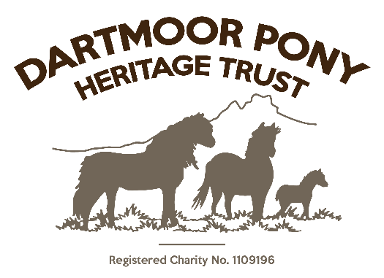

Harassment and Threatening Behaviour.

(Specifically, from members of the public)

March 2019

Introduction
1. Personal harassment takes many forms ranging from tasteless jokes and abusive remarks to threatening behaviour and actual physical abuse. Whatever form it takes, personal harassment and threatening behaviour is always taken seriously and is totally unacceptable.
2. The DARTMOOR PONY HERITAGE TRUST recognises that personal harassment can exist in the workplace, as well as outside, and that this can seriously affect employees' and volunteers’ working lives by interfering with their job performance or by creating a stressful, intimidating and unpleasant working environment, be it of only a temporary nature.

Policy
1. The DARTMOOR PONY HERITAGE TRUST deplores all forms of personal harassment and threatening behaviour and seeks to ensure that the working environment is sympathetic to all our employees and volunteers.
2. We have published these procedures to inform employees of the type of behaviour that is unacceptable and provide employees who are the victims of personal harassment, especially from members of the public, with a means of redress.
3. The DARTMOOR PONY HERITAGE TRUST recognises that we have a duty to implement this policy and all employees are expected to comply with it.

Examples of Harassment
Personal harassment and threats to a person can take many forms and employees, volunteers and visitors may not always realise that their behaviour constitutes harassment. Personal harassment is unwanted behaviour by one person towards another and examples of harassment include:
- lewd or abusive comments about appearance;
- displaying abusive or offensive writing or material;
- unwelcome touching; and physical assault;
- abusive, threatening or insulting words or behaviour.
These examples are not exhaustive and may be committed by visitors to the Centre intentionally or not.

Examples of Threatening Behaviour
Threatening behaviour can be directed against an individual or group that creates a threatening or intimidating situation which undermines the confidence and self-esteem of the recipient/s. Examples include:
- Verbal abuse eg. shouting, swearing at volunteers.
- Threats or insults.
- Practical jokes.
- Physical abuse.

Complaining about Harassment or Threatening Behaviour
1. Informal complaint
The DARTMOOR PONY HERITAGE TRUST recognises that complaints of personal harassment or threatening behaviour can sometimes be of a sensitive or intimate nature and that it may not be appropriate for you to raise the issue through our normal grievance procedure. In these circumstances you are encouraged to raise such issues with a Trustee of your choice as a confidential helper*. This person will then deal with the matter.
If you are the victim of harassment and/or threatening behaviour you should make it clear to the perpetrator on an informal basis that their behaviour is unwelcome and ask the perpetrator to stop and report the incident to a Trustee.

2. Formal complaint
Where the informal approach fails or if the behaviour is more serious, you should bring the matter to the attention of the Trustee on duty. Where necessary the matter can then be recorded by means of a formal written complaint and again the Trustee will assist you in this. If possible, you should keep notes of the behaviour that you find offensive so that the written complaint can include, where possible: -
- the name of the alleged perpetrator;
- the nature of the alleged behaviour;
- the dates and times when the alleged behaviour occurred;
- the names of any witnesses; and
- any action already taken by you to stop the alleged behaviour.
On receipt of a formal complaint, particularly if the incident involves an assault, we will take action to separate you from the alleged perpetrator to enable the Trustee to deal with the matter or to contact an outside agency such as the Police. Alternatively, the Trustee may require the person involved to leave the premises immediately. Should they refuse to do so then it may be necessary to involve the Police. Do not, under any circumstances, get further involved in a physical confrontation.

General Notes
1. If you bring a complaint of harassment or threatening behaviour you will not be victimised for having brought the complaint. However, if a report concludes that the complaint is both untrue and has been brought with malicious intent and brings the Charity into disrepute, action may be taken against you.
Victim Support
The DARTMOOR PONY HERITAGE TRUST will seek to provide additional assistance to victims by contacting outside agencies who will provide specialist advice and support, with the staff member’s permission. Notwithstanding that the matter can be dealt with internally, the choice being that of the victim.
Police Involvement
The DARTMOOR PONY HERITAGE TRUST will encourage and support victims to report acts of harassment and threatening behaviour and if deemed serious, to the Police. This support may include writing or telephoning the Police on behalf of the staff member, as well as attending meetings with the Police.
The DARTMOOR PONY HERITAGE TRUST will report incidents of harassment or threatening behaviour to the Police where there is a clear threat to the safety of other staff, volunteers, our property, animals or to the public.
Confidentiality
The DARTMOOR PONY HERITAGE TRUST will respect and maintain the confidentiality of matters concerning the employees and volunteers and of any members of the public giving information in harassment or incidents involving threats or physical violence incidents.
* The CONFIDENTIAL HELPER would normally be the most senior staff member or Trustee present

Review date: March 2021

